DC Motor Status using Arduino UNO

# Description:

In this project, we are using an Arduino Uno board to control the status of a DC motor. The motor can be turned on and off using a push button, and its status is displayed on an LCD display. The push button is connected to one of the digital pins of the Arduino board, and the DC motor is connected to one of the analog output pins. When the push button is pressed, the Arduino board reads the input and sends a signal to the motor to turn on. The LCD display then shows the status of the motor as "on". When the push button is released, the Arduino board sends a signal to turn off the motor and displays the status as "off" on the LCD display.

# Block Diagram :

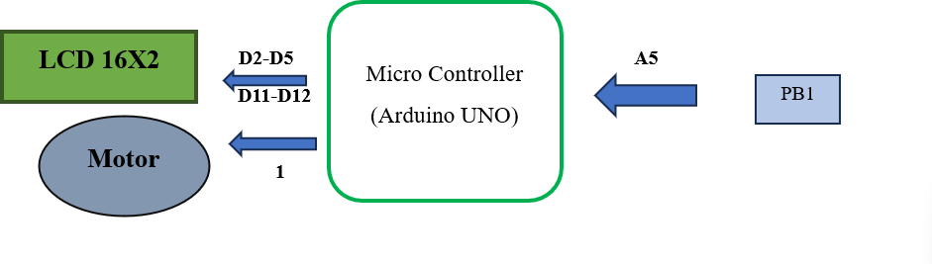

**Input and Output :**

|  |  |  |  |  |  |  |
| --- | --- | --- | --- | --- | --- | --- |
| **S.No** | **Description** | **Name** | **Type** | **Data Direction** | **Spectification** | **Remarks** |
| 1 | Button Pin | PB1 | INP | D1 | Digital | Active High |
| 2 | LCD RST | RS | OUT | DO | Digital | Active High |
| 3 | LCD EN | EN | OUT | DO | Digital | Active High |
| 4 | LCD DATA PIN | D4 | OUT | DO | Digital | Active High |
| 5 | LCD DATA PIN | D5 | OUT | DO | Digital | Active High |

|  |  |  |  |  |  |  |
| --- | --- | --- | --- | --- | --- | --- |
| 6 | LCD DATA PIN | D6 | OUT | D0 | Digital | Active High |
| 7 | LCD DATA PIN | D7 | OUT | DO | Digital | Active High |
| 8 | Motor | PD1 | OUT | AO | Analog | Active High |

# Souce Code :

#include <LiquidCrystal.h>

const int rs = 12, en = 11, d4 = 5, d5 = 4, d6 = 3, d7 = 2; LiquidCrystal lcd(rs, en, d4, d5, d6, d7);

const int motorPin = 1; const int buttonPin = A5;

// Variables

boolean motorOn = false; int motorStatusValue = 0;

void setup() {

// Set up motor and button pins pinMode(motorPin, OUTPUT); pinMode(buttonPin, INPUT_PULLUP);

// Initialize LCD lcd.begin(16, 2);

lcd.print("Motor: OFF");

}

void loop() {

// Read button state

int buttonState = digitalRead(buttonPin);

// If button is pressed, toggle motor state if (buttonState == LOW)

{

motorOn = !motorOn; digitalWrite(motorPin, motorOn);

// Update motor status value for analog output motorStatusValue = motorOn ;

// Update LCD display lcd.clear();

if (motorOn) { lcd.print("Motor: ON");

} else { lcd.print("Motor: OFF");

}

delay(2000);

}

// Update analog output for motor status analogWrite(motorPin, motorStatusValue);

}

Hardware

